Create a Freestyle project and name it as HelloWorldGitTrigger • Provide the repository path in Source Code Management section. You may have to fork the repository and give that URL in the source code management section • Enable GitHub hook trigger for GITScm polling under Build Triggers. • Select “Execute shell” under “Build” section. • Enter the commands javac HelloWorld.java • Save the configuration • Enable webhook in GitHub, under settings ->Webhook. Webhook could be found from Manage Jenkins -> Configure System -> GitHub ->Advanced - > Enable Specify another hook URL for GitHub configuration [http://:8080/github-webhook/](NULL)

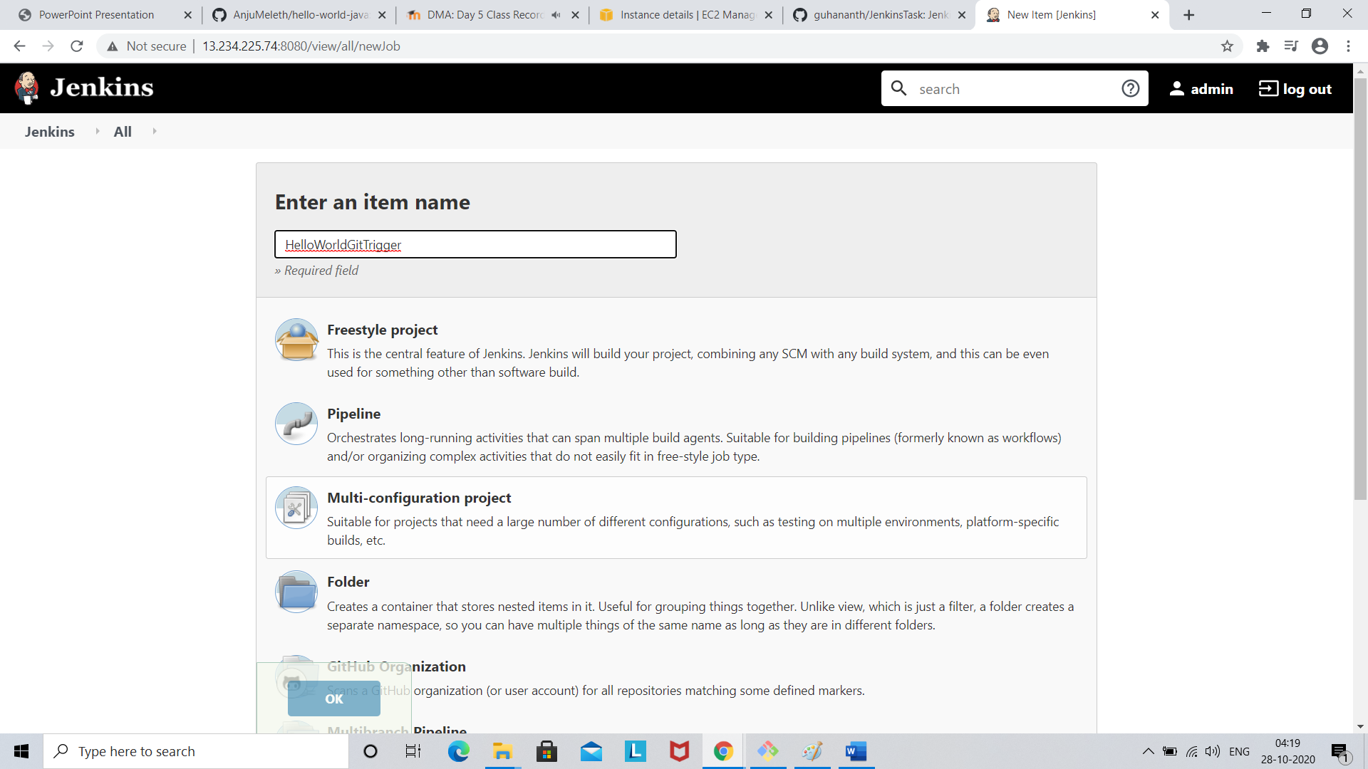

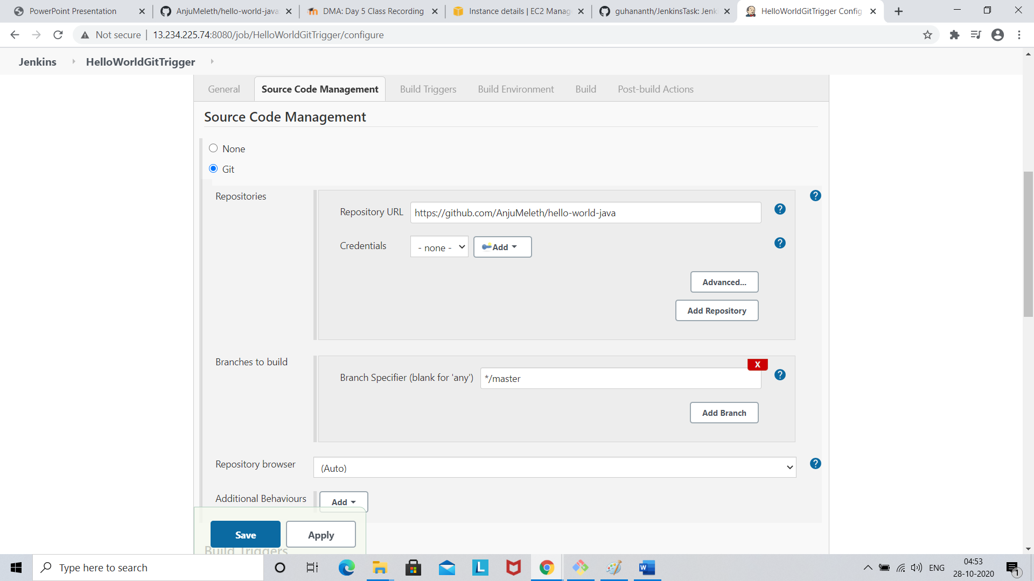

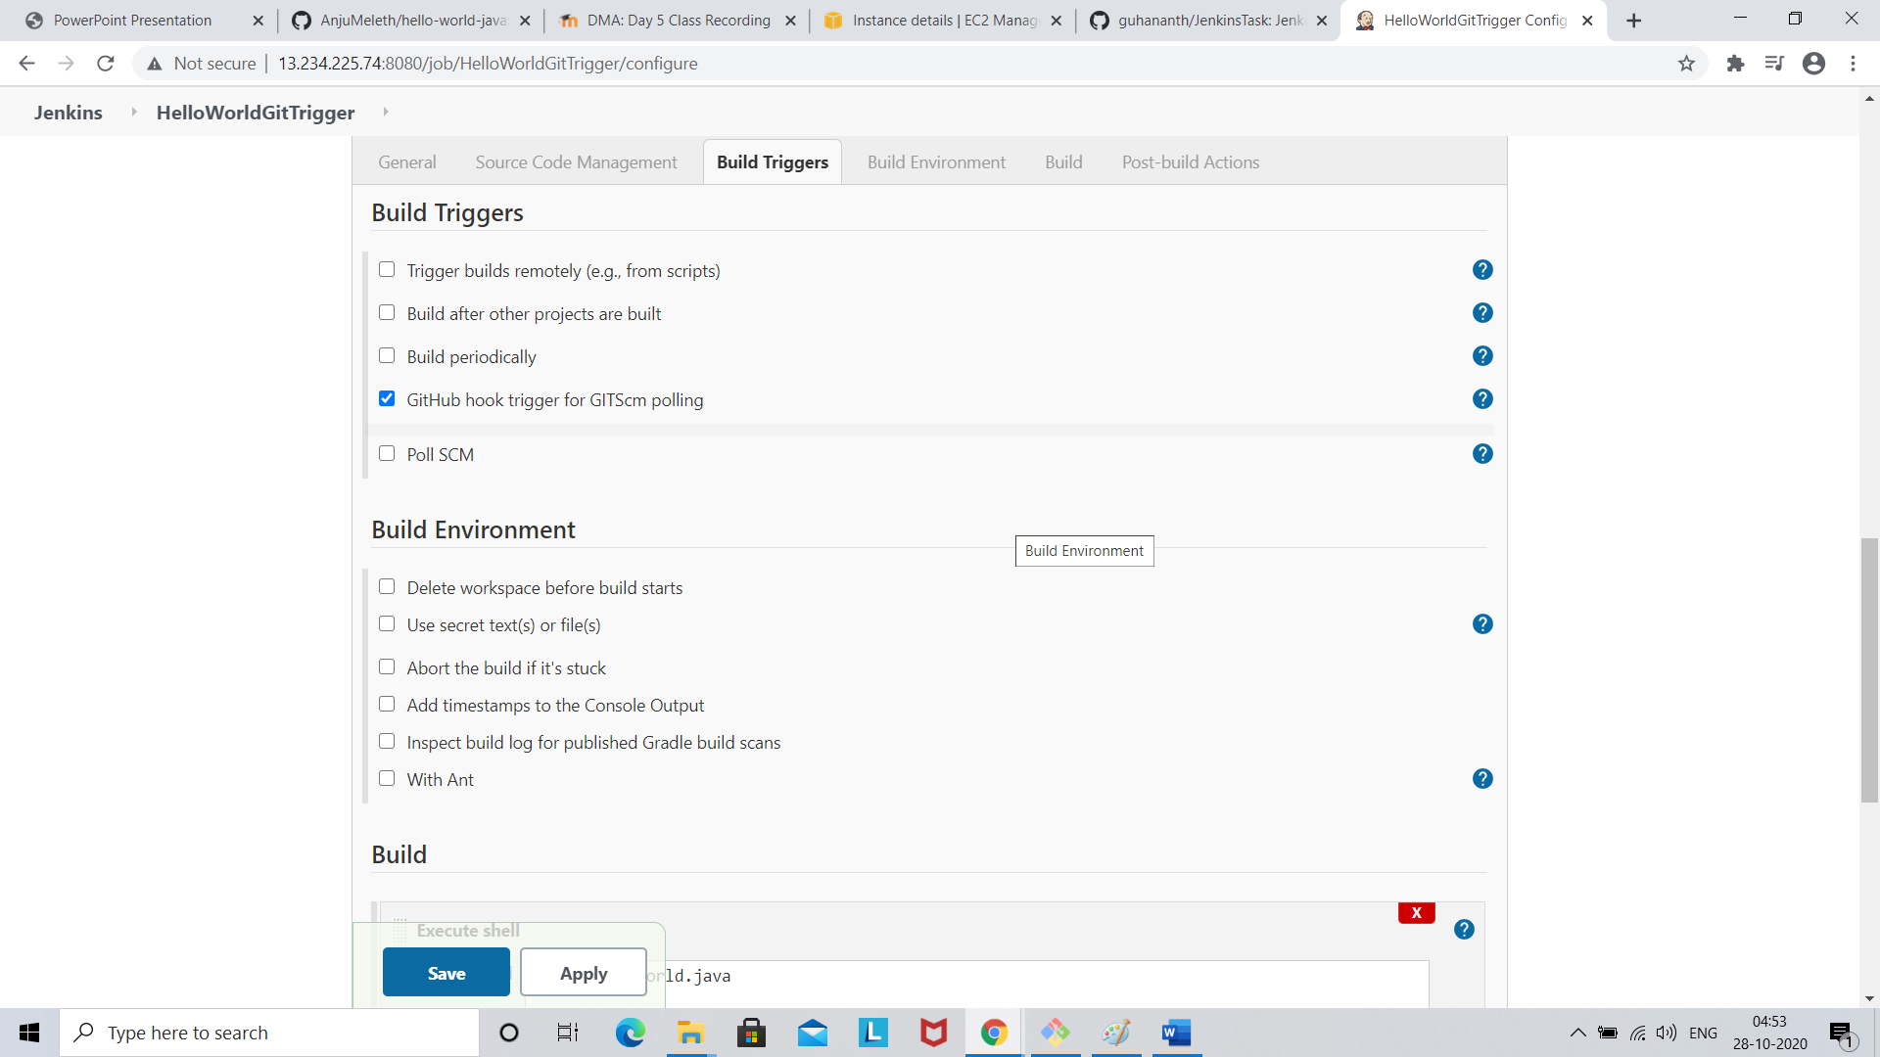

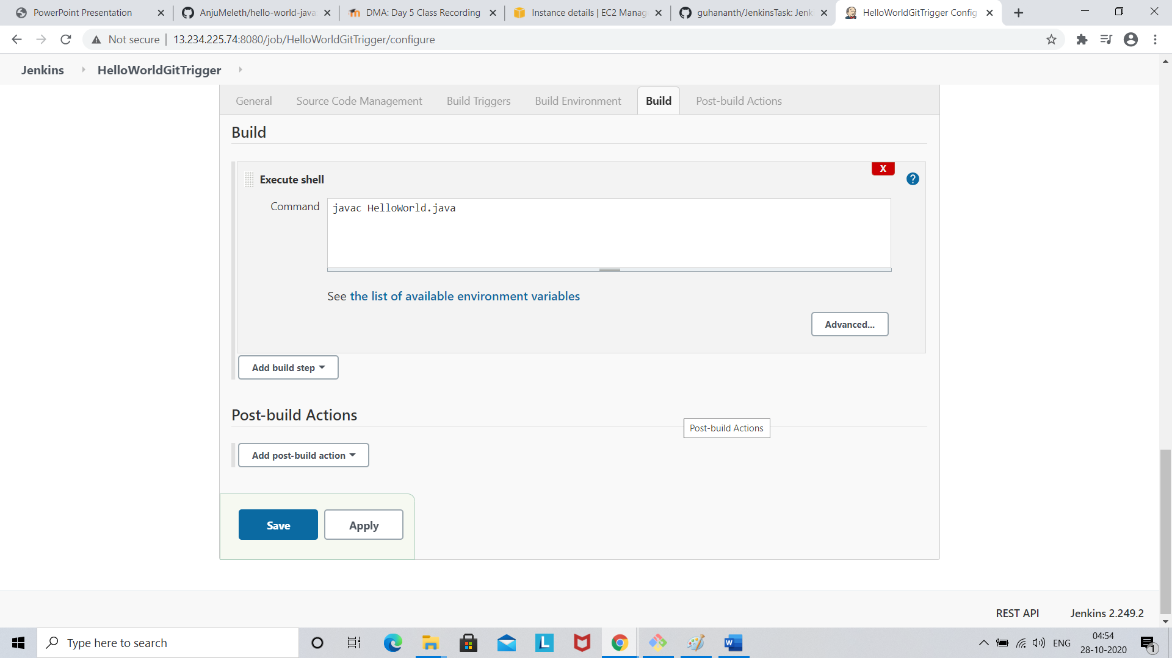

In Home go to Manage Jenkins

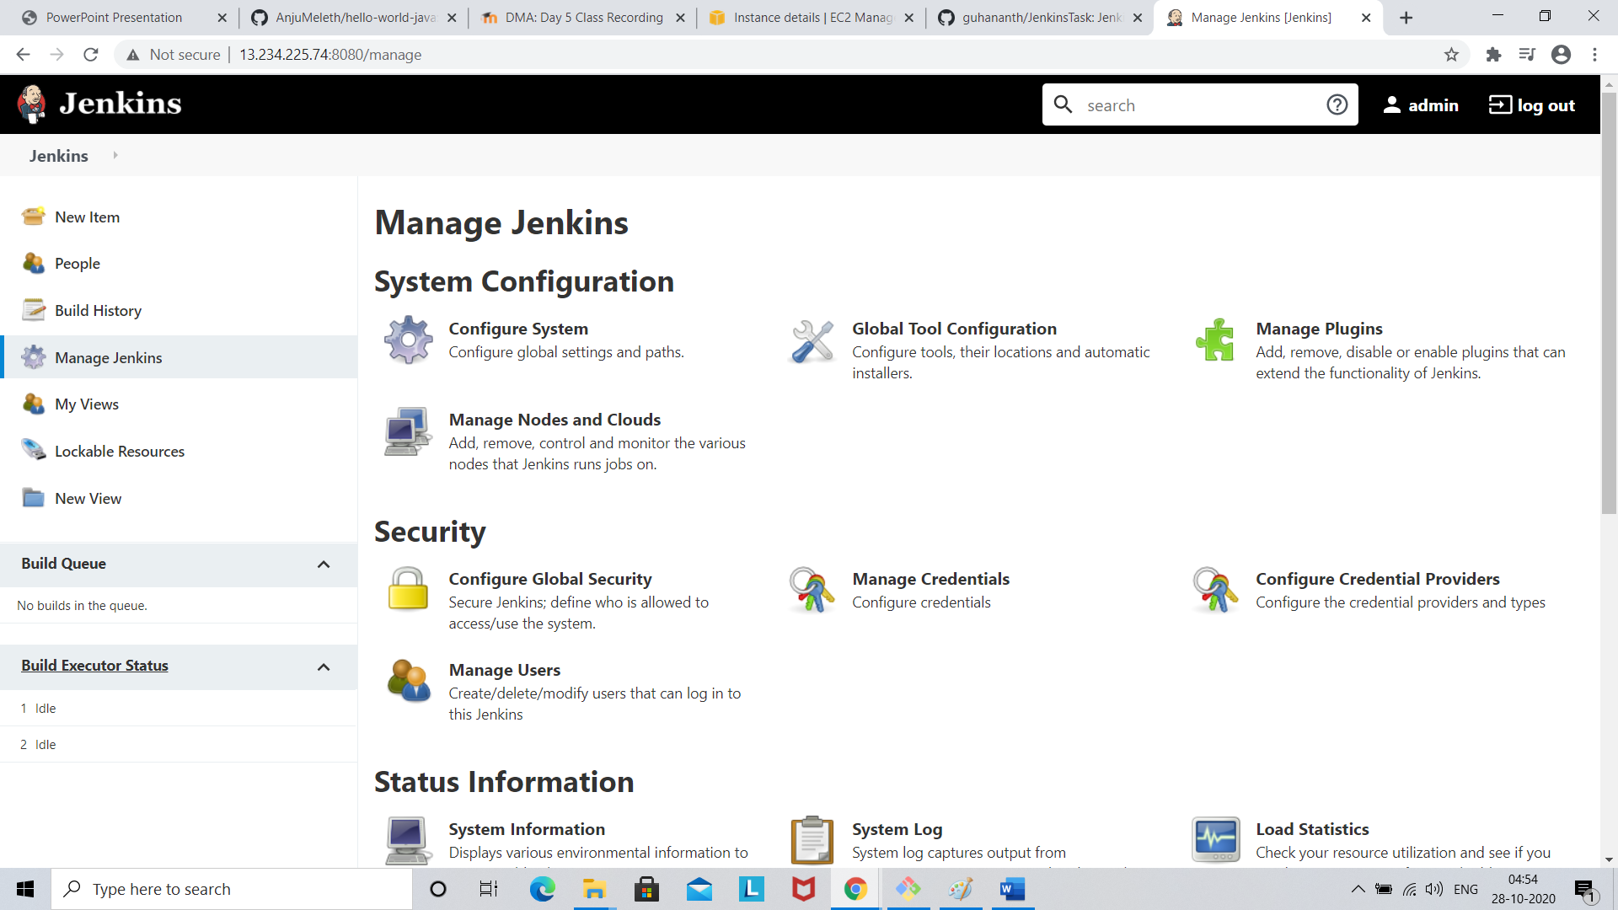

Click system configuration

Got to Git hub , select Advanced button

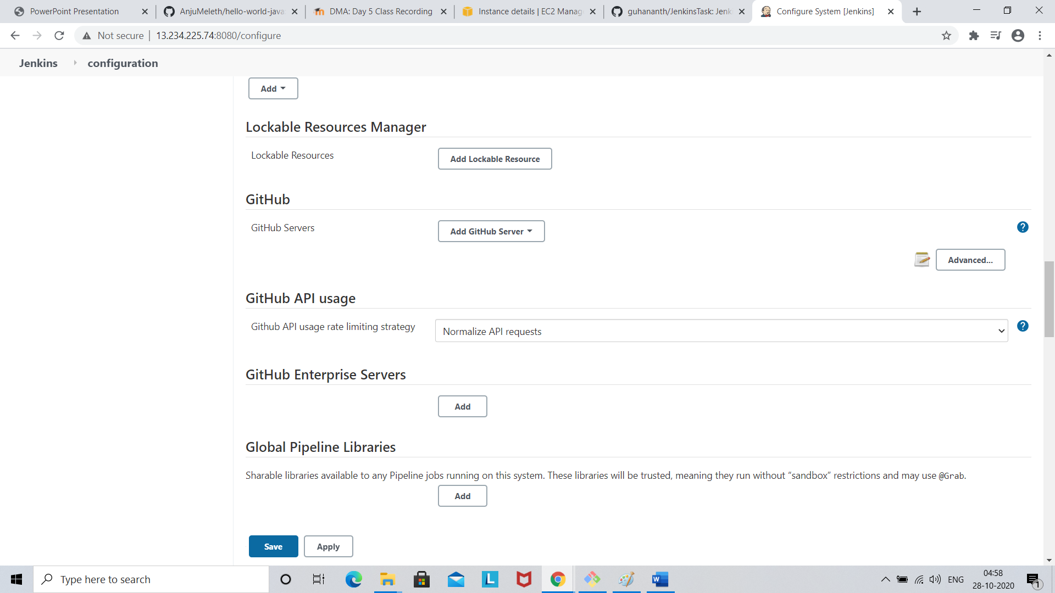

Check Override Hook URL checkbox

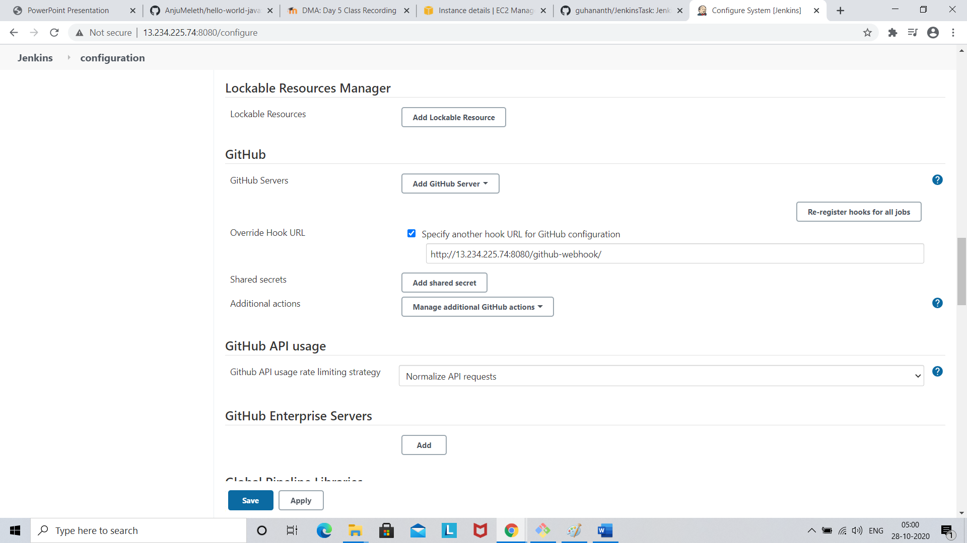

In github enable a push event

Then in Jenkins build

